|  |  |
| --- | --- |
| **STUDENT PORTFOLIO** | |
|  | **Name: Abhijeet Dhankar**  **Register Number:RA2111028010101 Mail ID:** [**ap4603@srmist.edu.in**](mailto:ap4603@srmist.edu.in) **Department: CSE**  **Specialization: Cloud Computing Semester: 3rd** |
| **Subject Title: 18CSC201J Data Structures and Algorithms**  **Handled By: Dr. V. Pandimurugan** | |

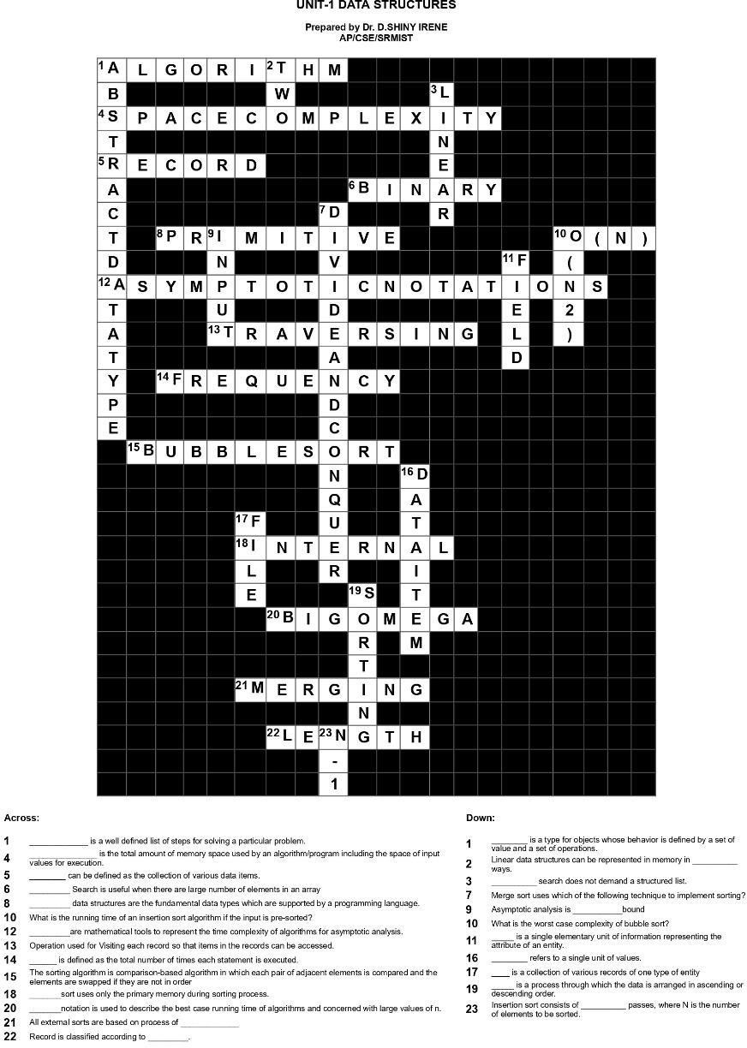

**Assignment – CrossWord Puzzle (Unit 1,2,3, & 4)**

**(Write about the assignment questions and how u solved differently)**

**It was very Challenging and helpful for me to solve these puzzles and it really helped**

**me to knowledge.**

**brush up my**

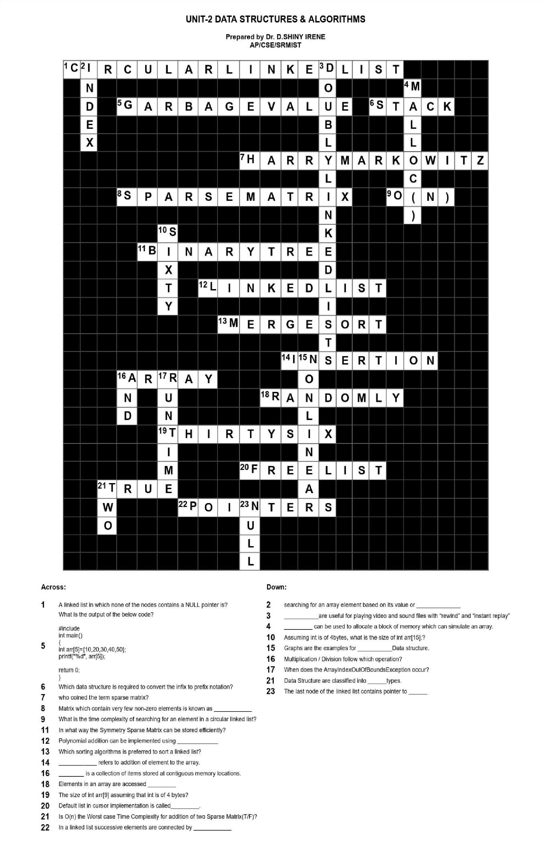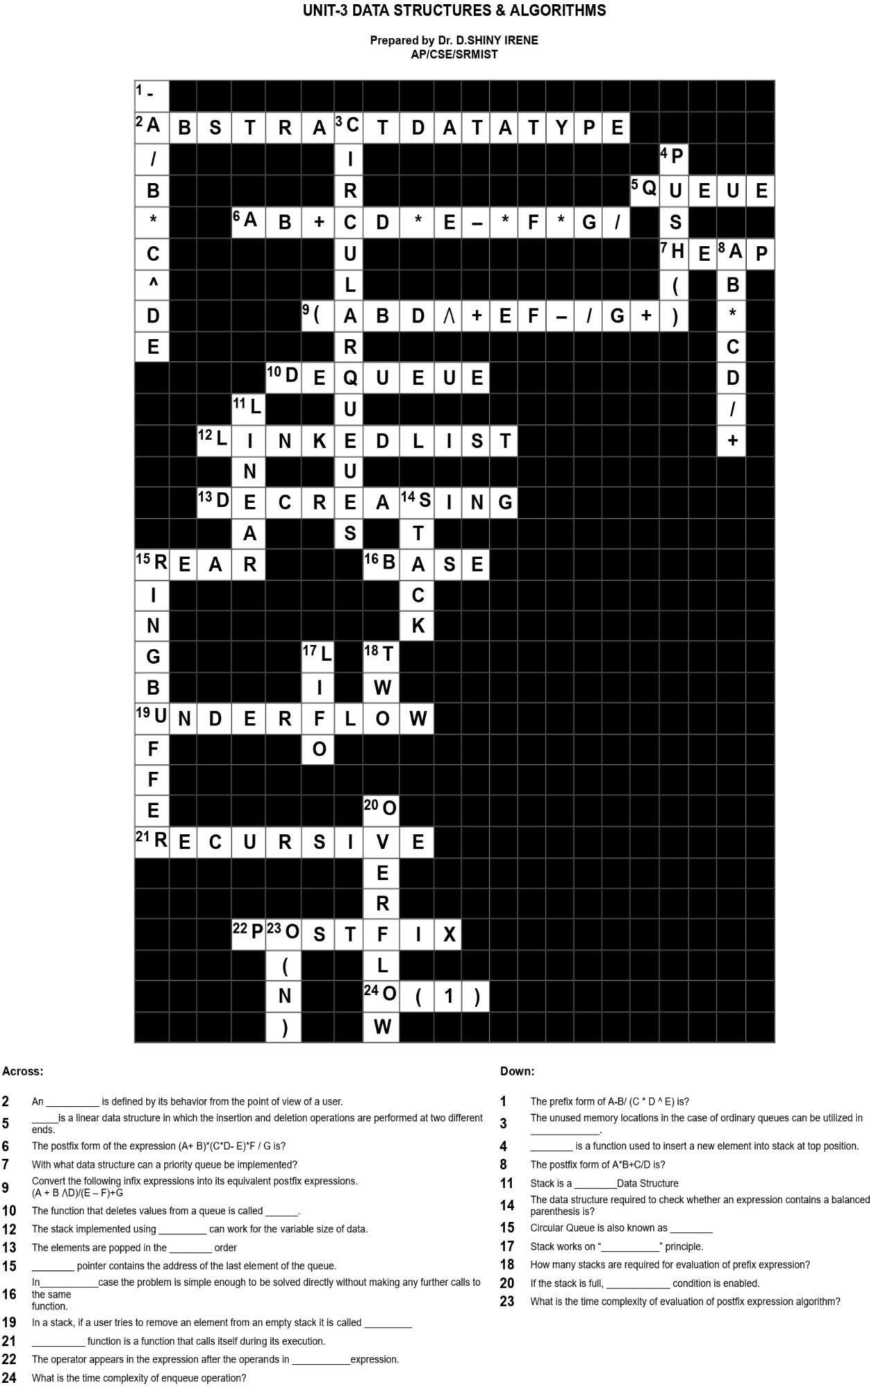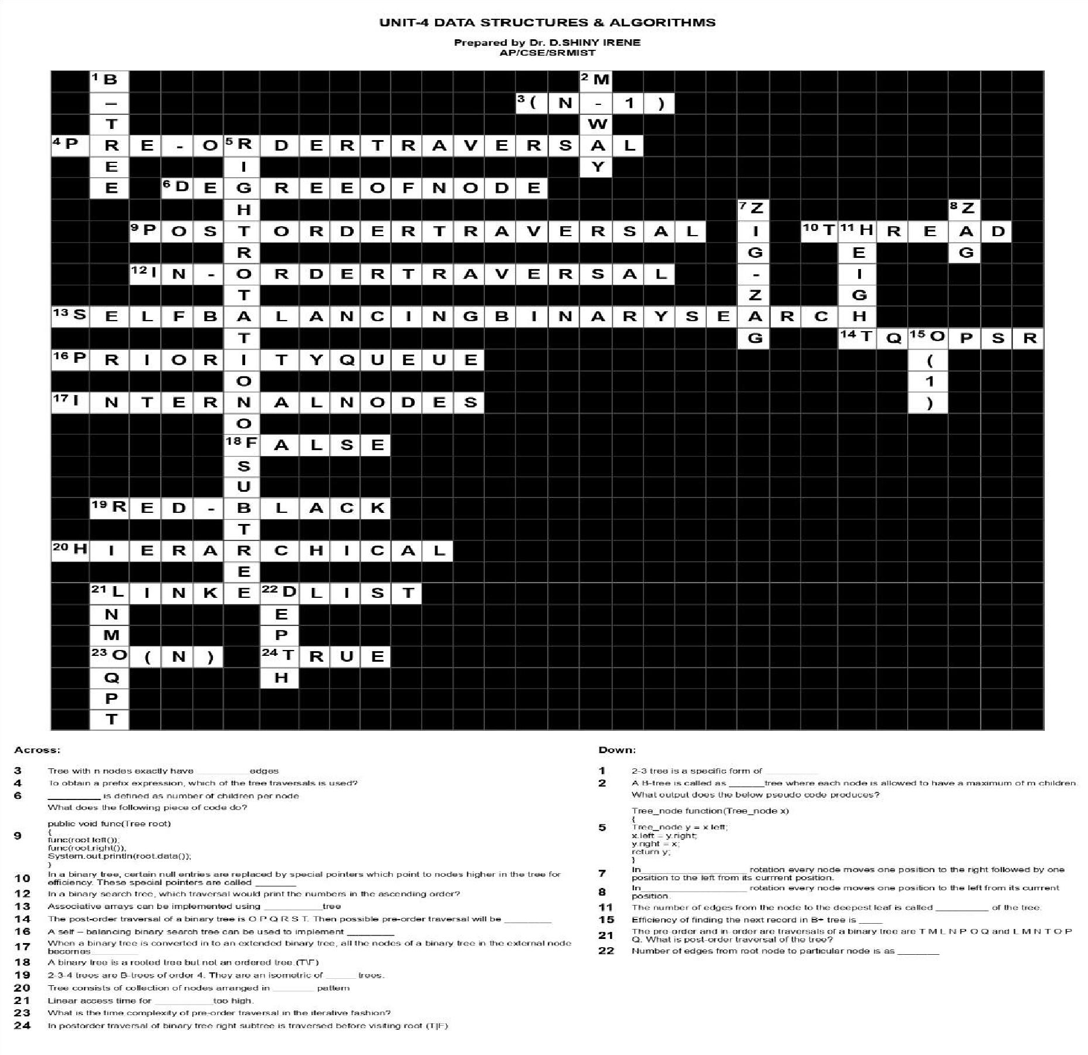

Assignment

(what is the most interesting part in the assignment)

The most important part in the assignment are as follows – • Solving the infix to postfix notations

* Creativity in solving the crosswords
* Finding the outputs
* It helps to enrich my skills

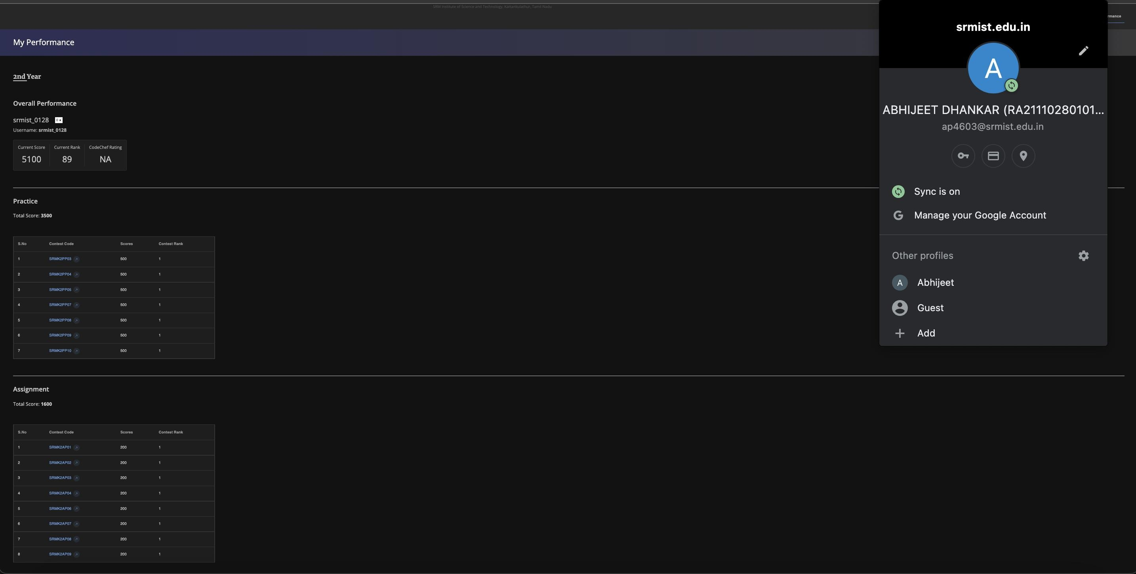



**Codechef Achievements**

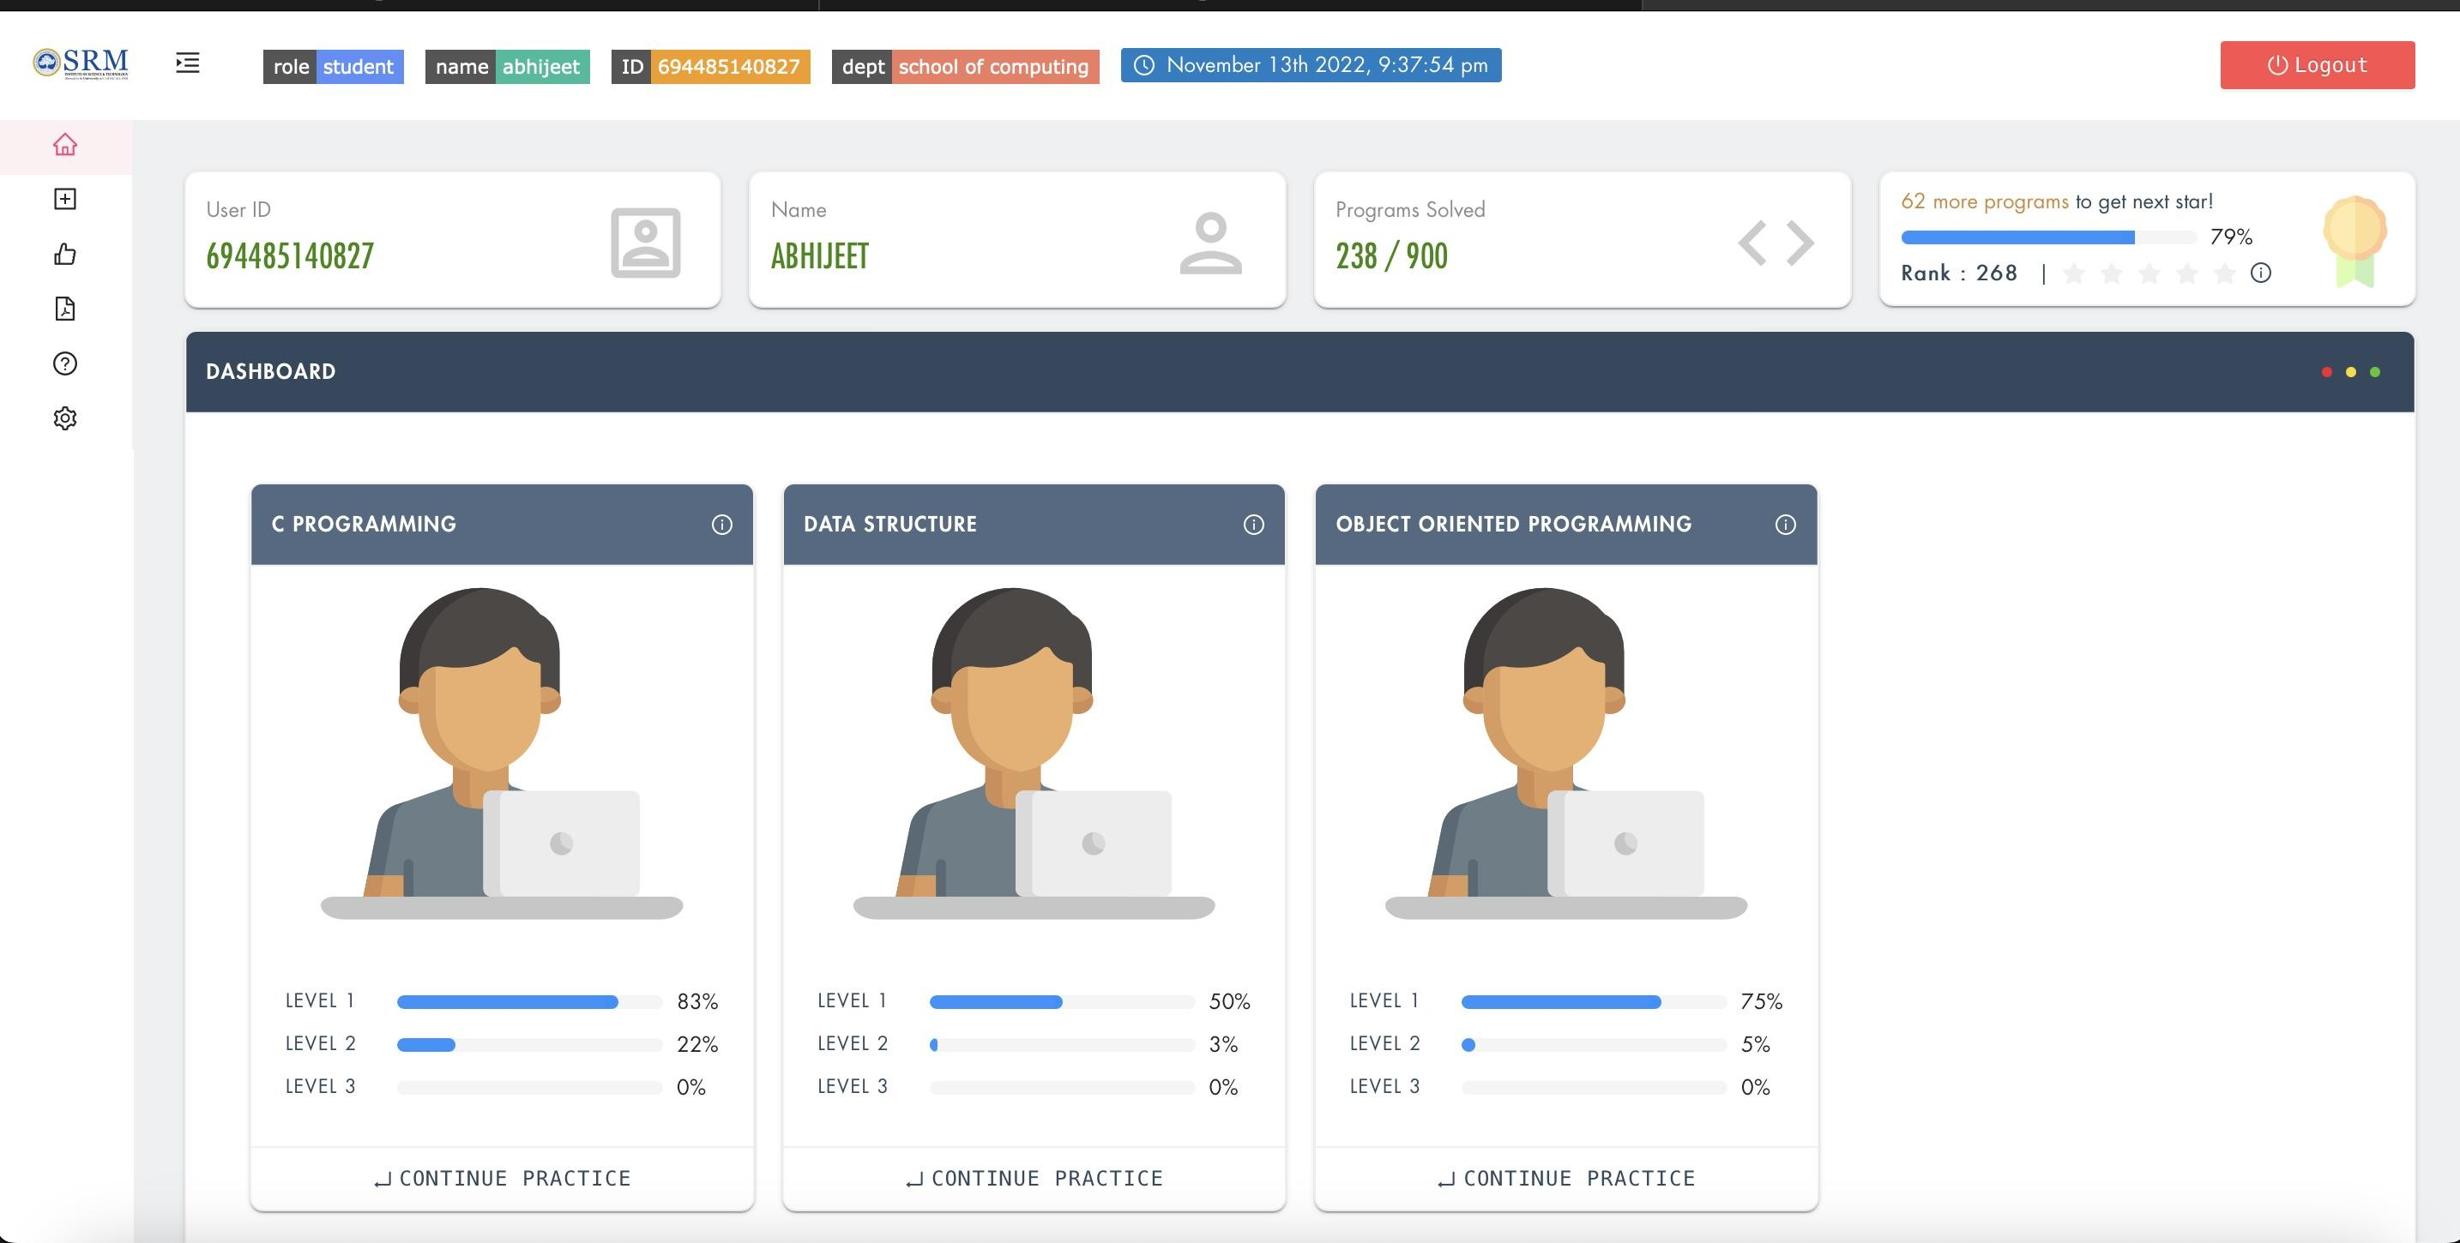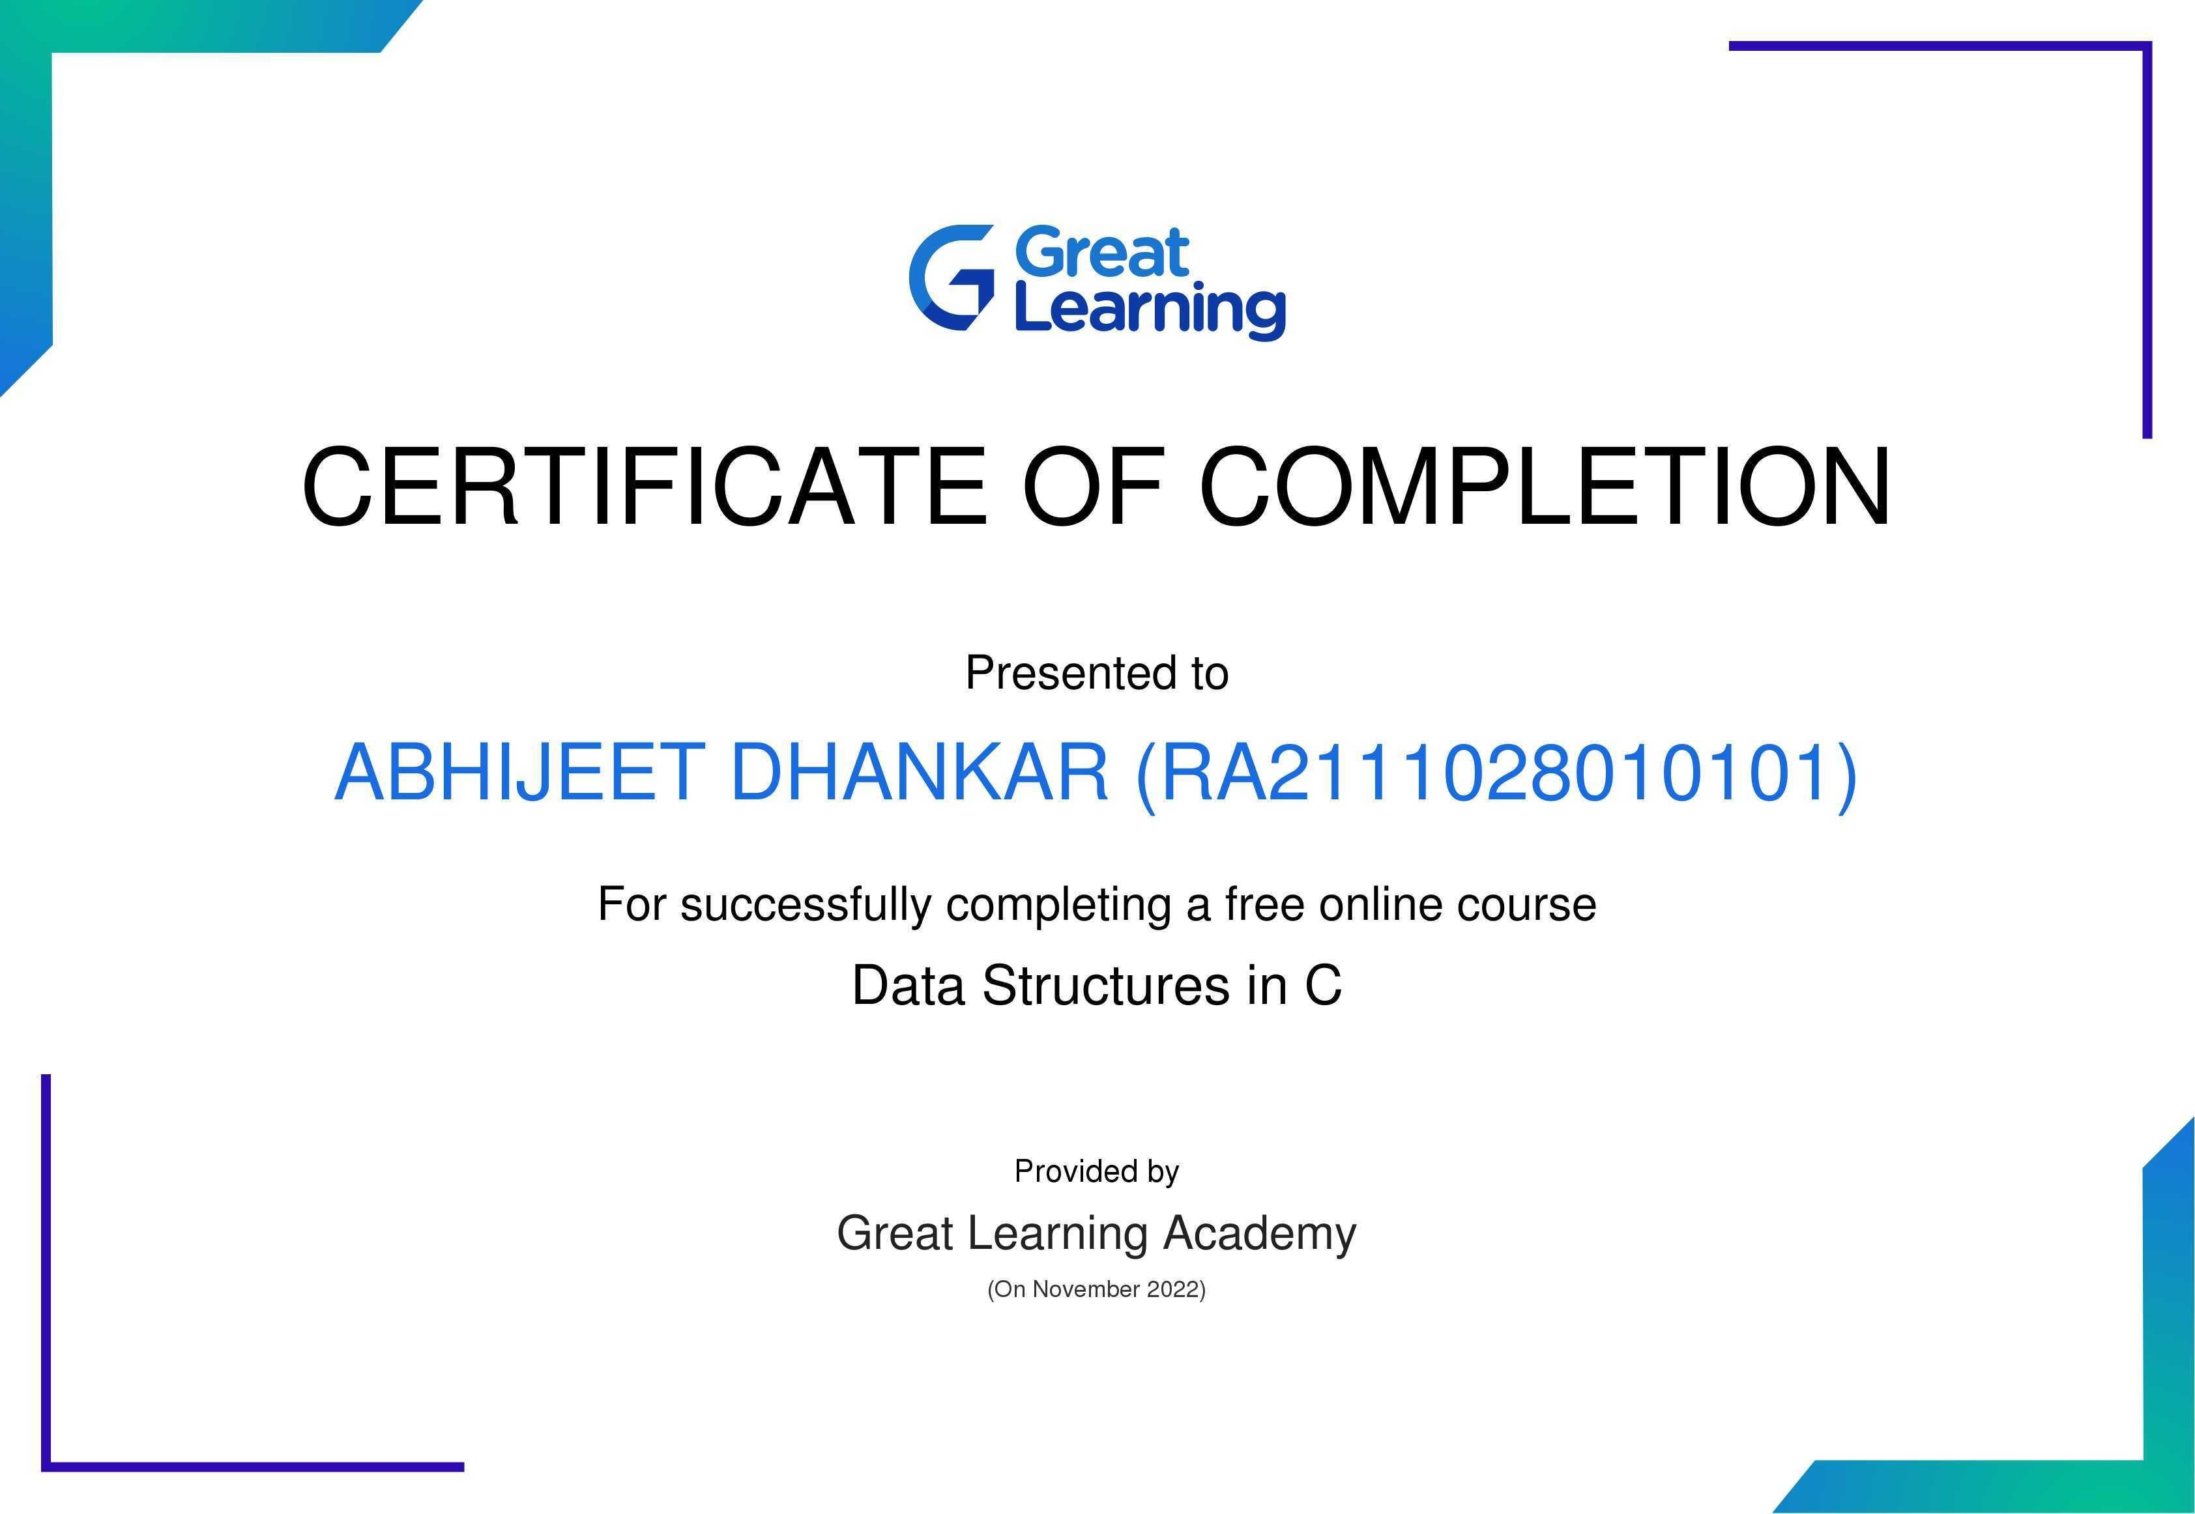

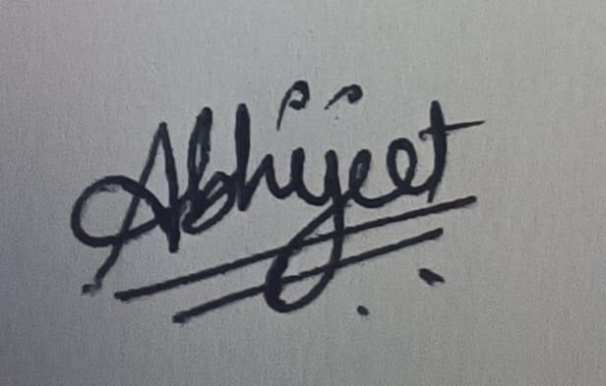

**Signature**

**Note: Enclose the assignment and relevant certificates along with the profile**